The Geometry Of Musical Logarithms 2

Fig. 1 Descartes Prænotanda: Arithmetic vs. geometric division 2

Fig. 2a Fogliano (1529): Geometric mean 2

Fig. 2b. Descartes’s example in the light of Fogliano’s construction. 2

Fig. 3 Interval and pitch classes according to Descartes 3

Fig. 4. Jost Buergi, *Arithmetische und geometrische Progress-Tabulen* (1620) 5

Fig. 5 Pitch classes as a mathematical transformation 6

Fig. 6a Fludd circles 6

Fig. 6b Numerationis Speculum 7

Fig. 7 Fretboard of the barbitum. Resolves Fig. 6a 7

Fig. 8 Fludd’s Speculum adapted 8

Fig. 9 Descartes’s instrument to construct geometric progressions 8

Fig. 10 The division of the whole tone 9 : 8 into semi-tones 17 :16  and 18 : 17 (Zarlino 1571) 9

Fig. 11 Beeckman chromatic and diatonic scale 9

Table 1 Analysis of the chromatic scale given by Beeckman. 9

Table 2 Bürgi’s geometric/arithmetic progression 10

Fig. 12 Pascal’s Triangle according to Stifel 1544 10

Fig. 13a Tetraktys 10

Fig. 13b Division of the octave 6 : 8 : 9 : 12( Zarlino 1571). 10

Fig. 13c Division of the double octave 6 : 8 : 9 : 12 : 14 : 16 : 18 : 24 and the Pythagorean chromatic scale (Faber Stapulensis 1551, 32v) 11

Fig. 14a Power table (filled Lambda tetraktys) 11

Fig. 14b Fludd triangle 12

Fig. 14c Torkessy etc (Reany/Gilles p. 28) 12

Fig. 14d Boethius Arithmetic triangle (Mh 1) 12

Fig. 15 Power tables as a self-similar structure 13

Fig. 16 Two dimensional Pythagorean power grid. 13

Fig. 17a Diatonic Pythagorean scale 14

Fig. 17b 53 Pythagorean fifths filling Descartes’s pitch circle (n = 53). 14

Fig. 18a Syntonic pitch grid (Rameau 1726) 15

Fig. 18b 1739_Euler__Tentamen_147_ChromaticScale.jpg 15

Not used 17

Table 2 Multiple, superparticular ratios 17

Table 3 The intervals of the tetraktys 17

Torkessy etc (Reany/Gilles p. 30, 61) 17

1617_Fludd_1_Tract_I_Lib_VI_fol181_CausarumUniversaliumSpeculum.jpg 18

Ramon Llull, Ars brevis (1305) 19

# The Geometry Of Musical Logarithms

#### Fig. 1 Descartes Prænotanda: Arithmetic vs. geometric division

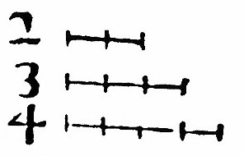 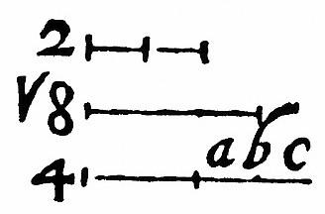

**Fig. 1.** Arithmetic versus geometric division of the ratio 2 : 4, leading to the division of the octave into a Pythagorean fifth and fourth versus two equal diminished fifths, or ‘semi-octaves’.

#### Fig. 2a Fogliano (1529): Geometric mean

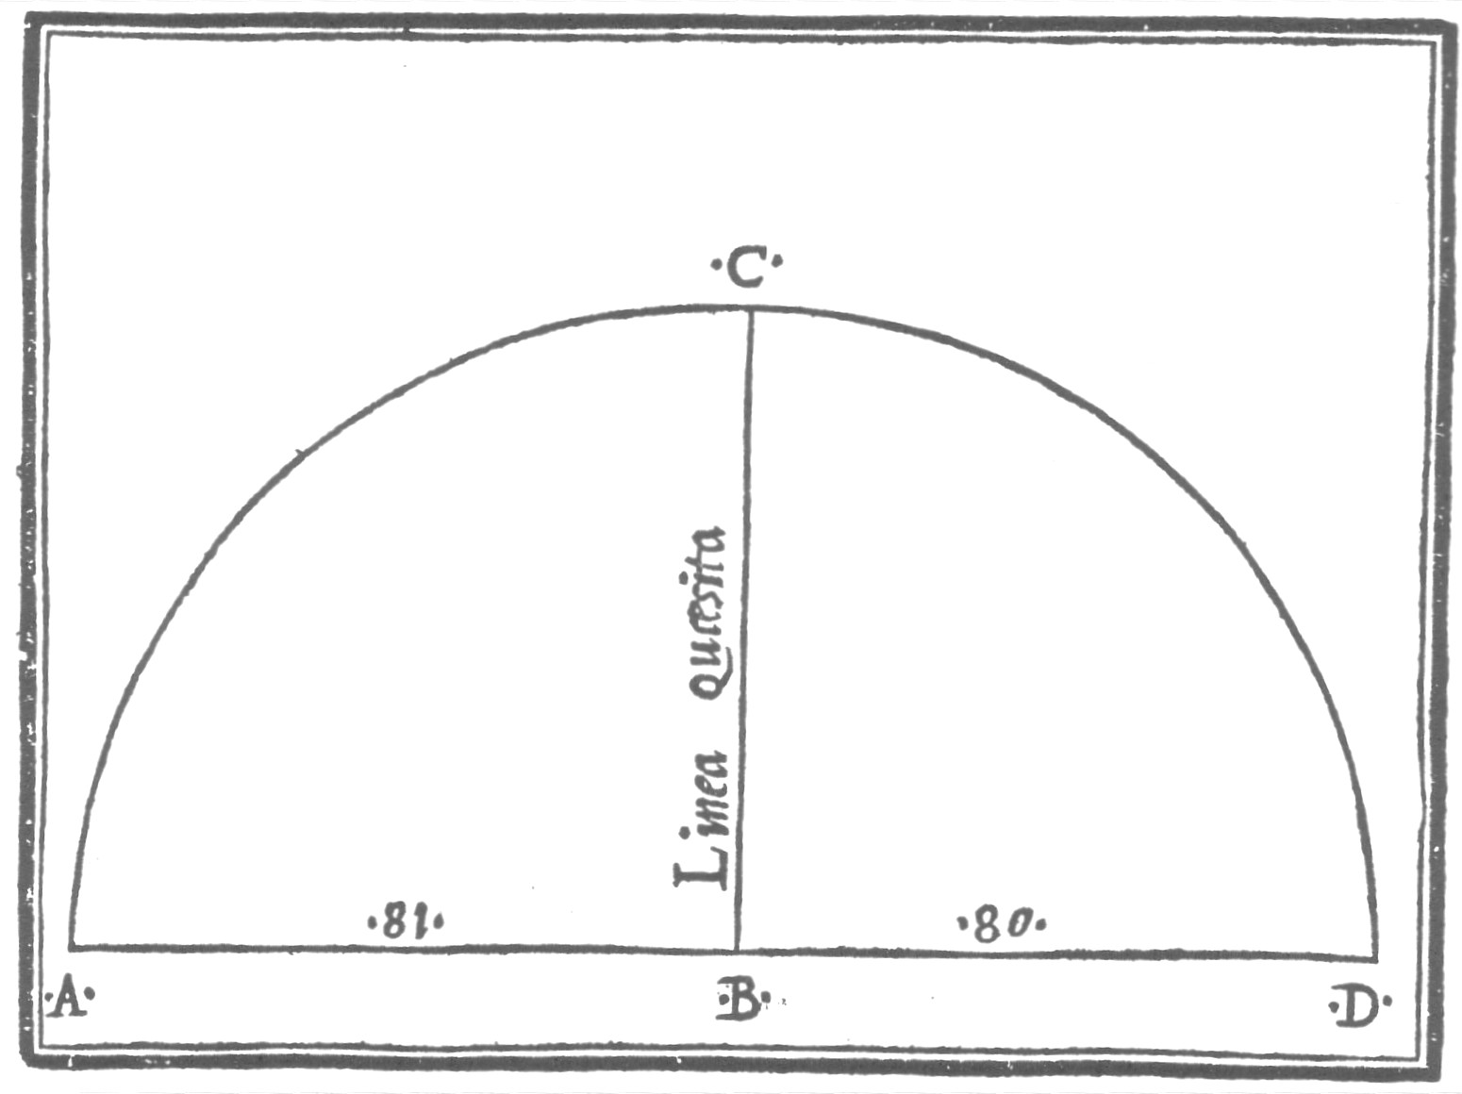

**Fig. 2a.** Construction of the geometric mean of 80 and 81 by Fogliano (1529) leading to the musical interval of half a syntonic comma.

#### Fig. 2b. Descartes’s example in the light of Fogliano’s construction.

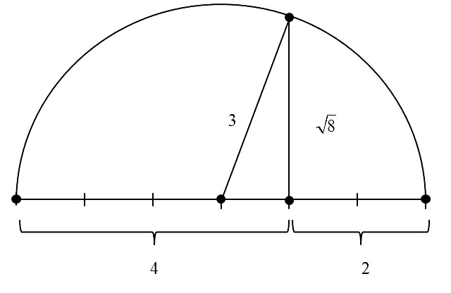

#mz_geometricMean_2_4.jpg#

#### Fig. 3 Interval and pitch classes according to Descartes

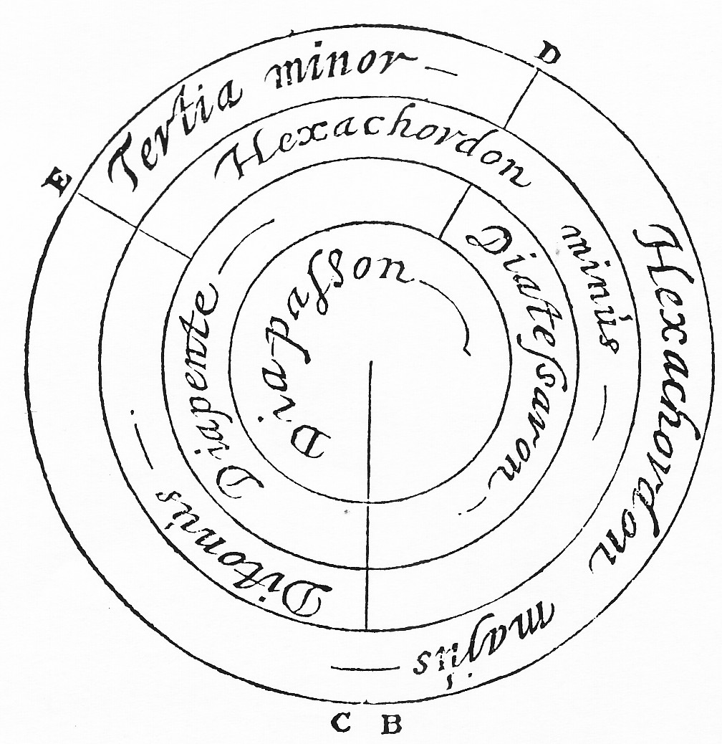 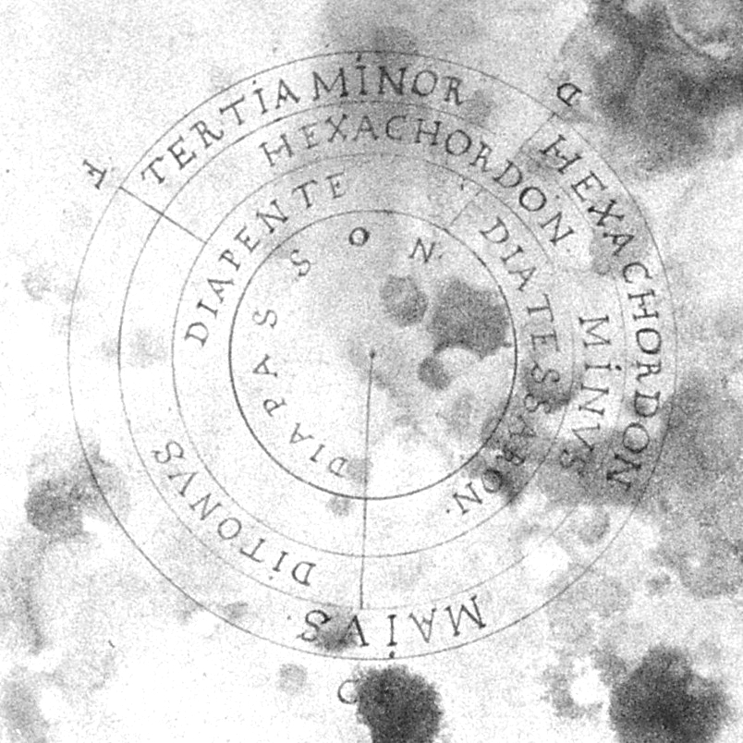

**Fig. 3a.** Left: The consonant intervals within the octave (Diapason) according to Descartes. The closing of the octave happens at the bottom CB, where the fifth (Diapente) and the major third (Ditonus) start. The minor third is unusually called Tertia minor and not Semiditonus, however, the major third comes as Ditonus and not as Tertia major. Subtracting a consonant interval from the octave gives always a consonant interval. The minor third is defined as the fifth minus the major third, which is indicated by the radial line segments through E and D.

Right: The diagram in Beeckman’s copy: The angle for the minor third seems to be much bigger than 90° because the divider line does not pass through the clearly indicated centre of the circles.

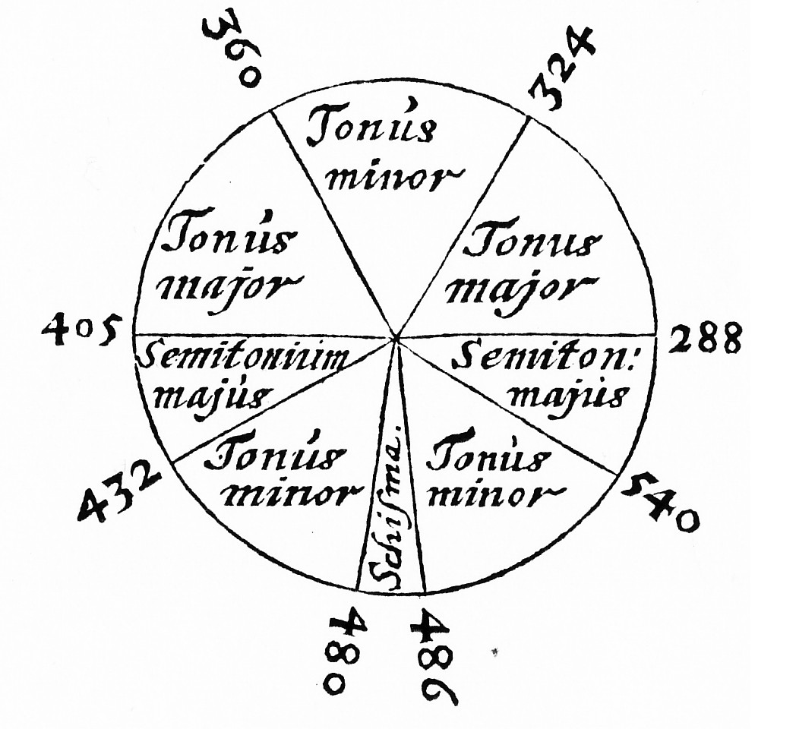 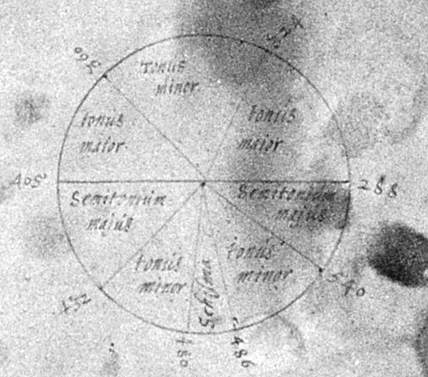

**Fig. 3b.** The diatonic major scale, starting at ut = 540 in clockwise direction with an ambiguous tone (486/480), separated by a syntonic comma which Descartes calls *Schisma*. The diagram is completely symmetric about the bisector of the syntonic comma. The radii defining the tritone and the diminished fifth (at 405 and 288) are hardly distinguishable from a straight diameter.

In Beeckmans’s copy the symmetry about a vertical is still recognizable in the lower part. However, the angle of the major tone 405‑360 is about the size of the minor thirds in the lower part and the angle of the minor tone 360‑324 is about the size of the accurate major tone 324/288.

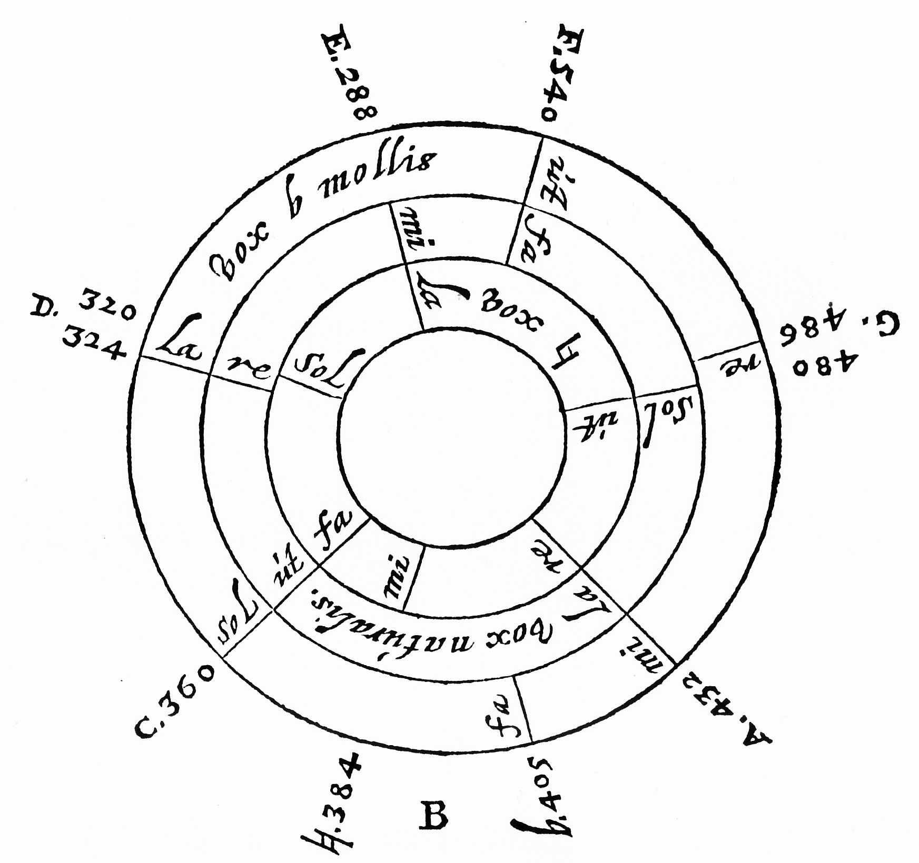 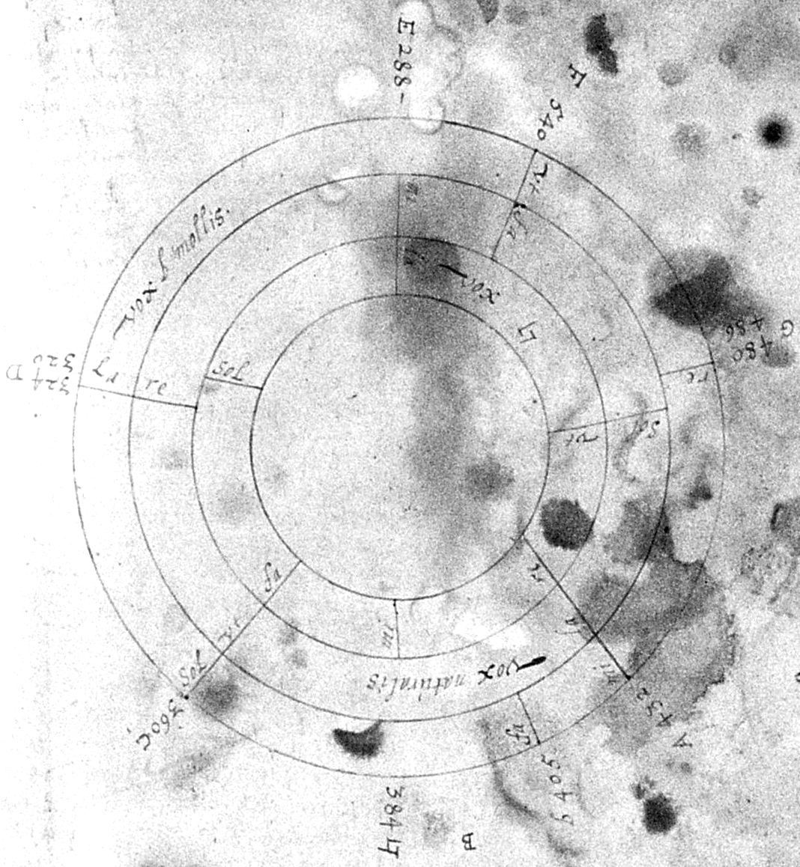

**Fig. 3c.** The three hexachords from F (540), C(360) and G(480) have congruent angles, each given with relative solmization. The leading notes B quadratum (384) and E (288) are a byproduct of the hexachords (ut, re, mi, fa, sol, la). There are two ambiguous pitch classes at G and D. Note again that the diminished fifths (540‑384 and 405‑288) ‘mi contra fa’ (the devil in music) are on diameters of the circle.

In Beeckman’s copy both tritones are far from being on diameters, and the fifth 288‑384 (E‑B quadratum) is close to the vertical diameter. Many of the radial dividers do not pass through the common center of the circles, which makes a quantitative evaluation of the angles problematic.

#### Fig. 4. Jost Buergi, *Arithmetische und geometrische Progress-Tabulen* (1620)

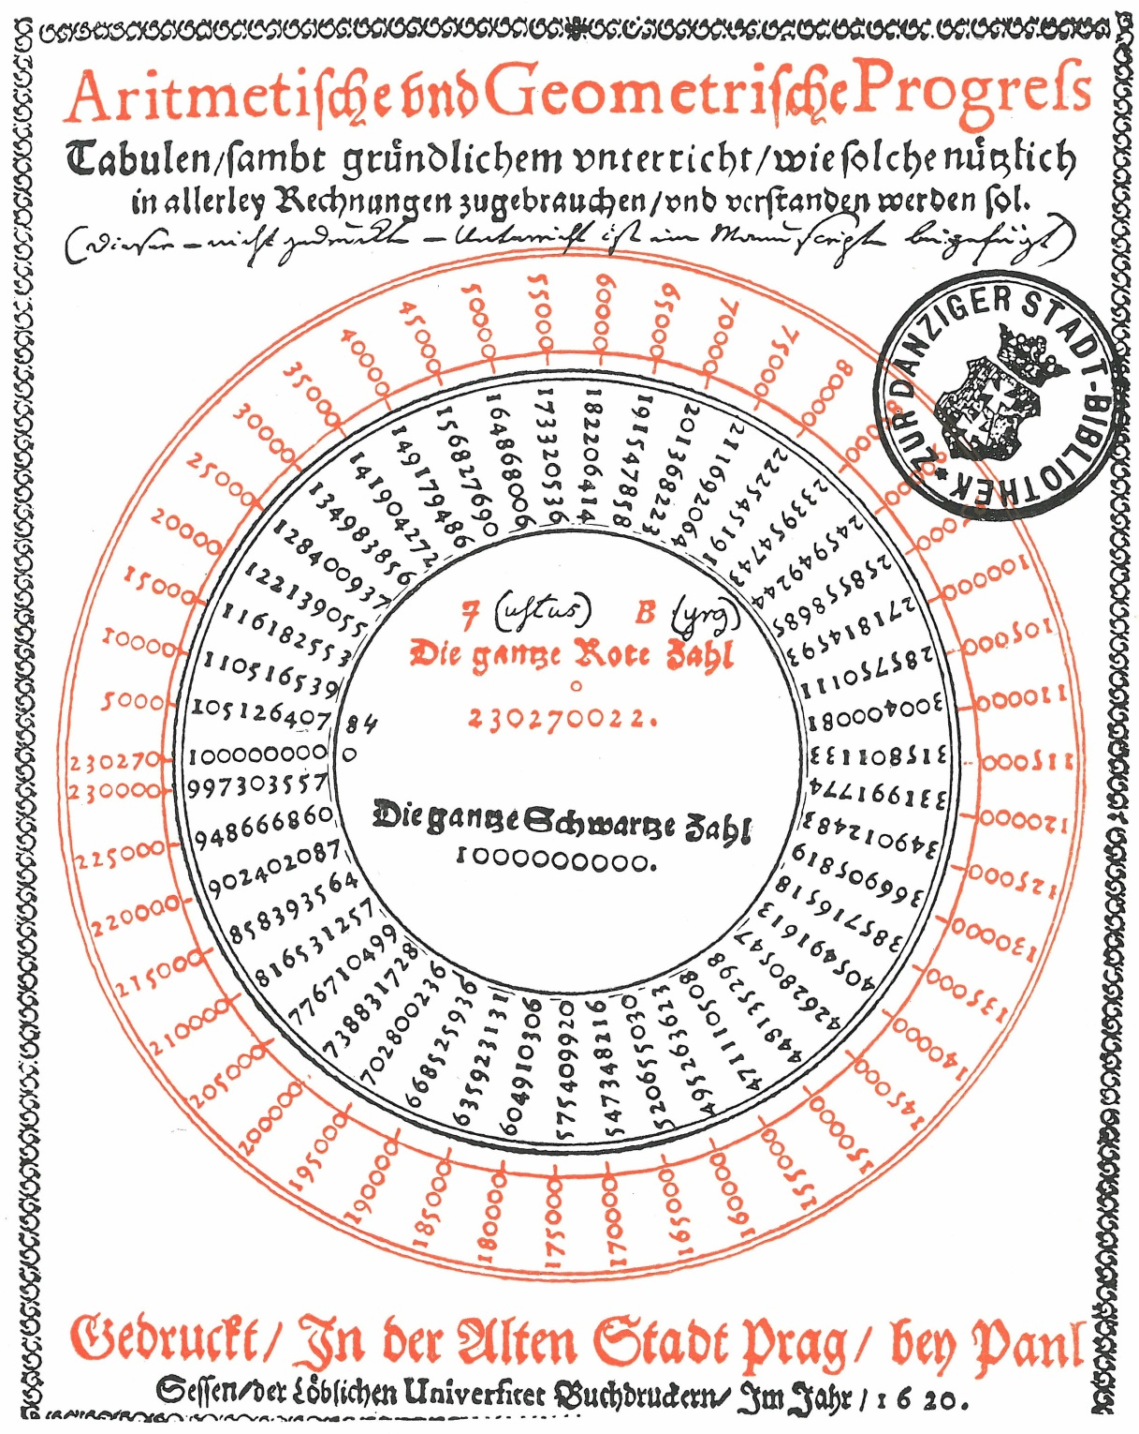

Title page of Jost Bürgi’s power tables. The black numbers of the inner circle run from 1 to 9.9973... The red numbers, running from 0 = 230’270 in steps of 5000 (actually 500.0), are the power indices with respect to the base 1.0001 of the black numbers. The small circle above the red number in the center of the diagram indicates the decimal point. The points at the end of the numbers are full stops… (1.000123027.0022 = 9.999’999’997 = 10.000’000’00).

#### Fig. 5 Pitch classes as a mathematical transformation

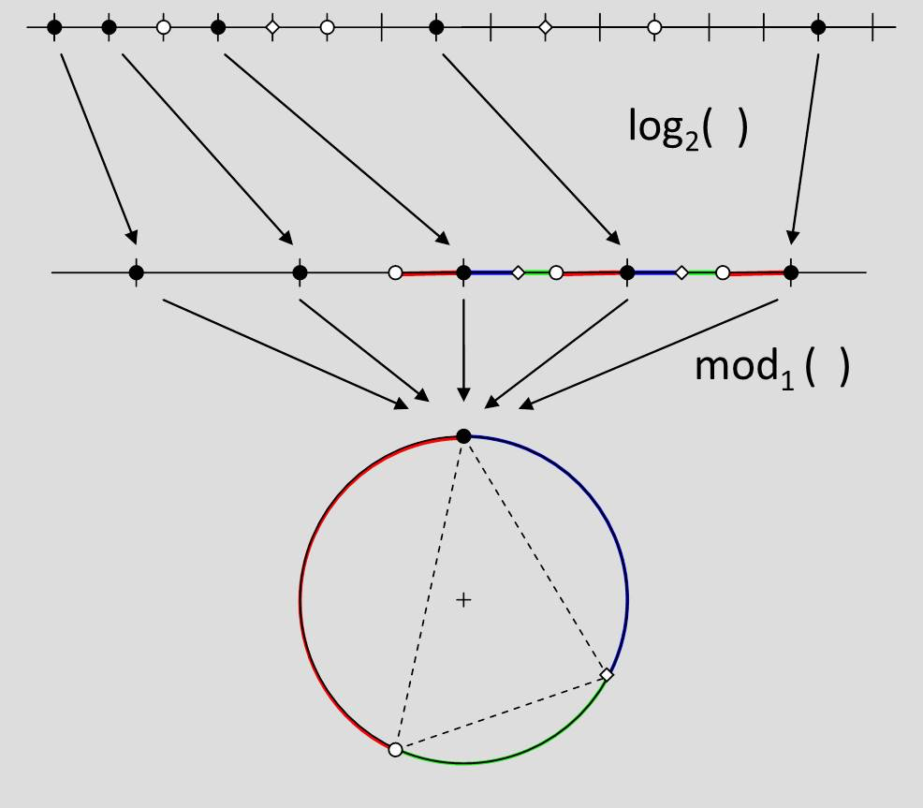

#mz_log2_mod1.jpg#

#### Fig. 6a Fludd circles

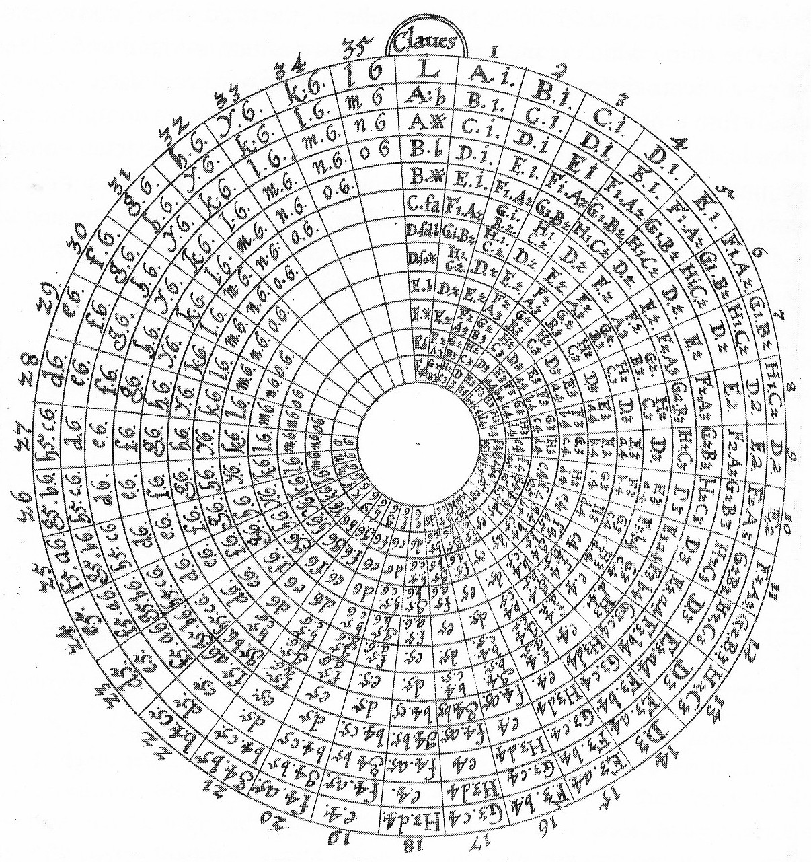

Transposition circle of the lute with a chromatic scale of semitone running from 1 = *A*1, the lowest tone on the lowest string, to the highest tone 35 = *o*6 of the third circle, which is 3 octaves plus two semitones higher than the lowest note. The vertical chromatic scale below ‘Claues’ (keys) with tone names is meant to be a spinner. Therefore the full circle covers three octaves [UCH Vol I, Tract II Part II Lib VI, (De Instrumentis Musicis vulgariter notis): 232: Transposition Circle (230: Fretboard)].

#### Fig. 6b Numerationis Speculum

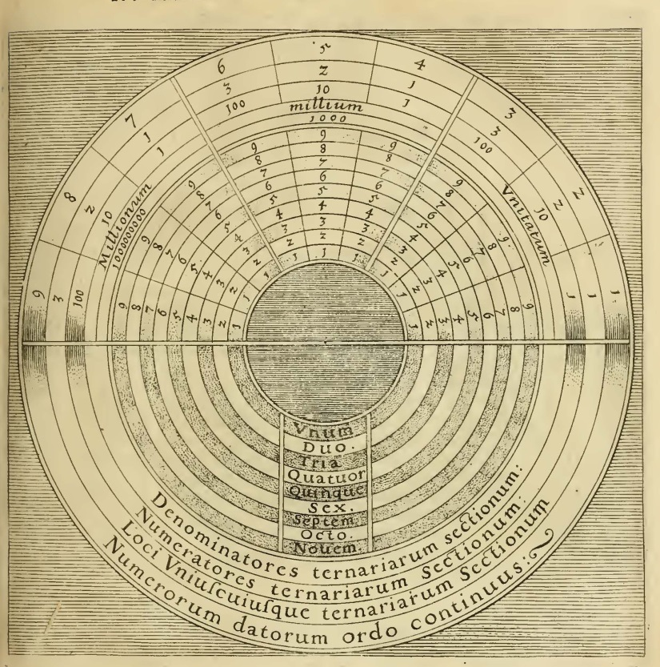

UCH Vol I, Tract II Part I Lib I, 9 (De Numero et Numeratione)

#### Fig. 7 Fretboard of the barbitum. Resolves Fig. 6a

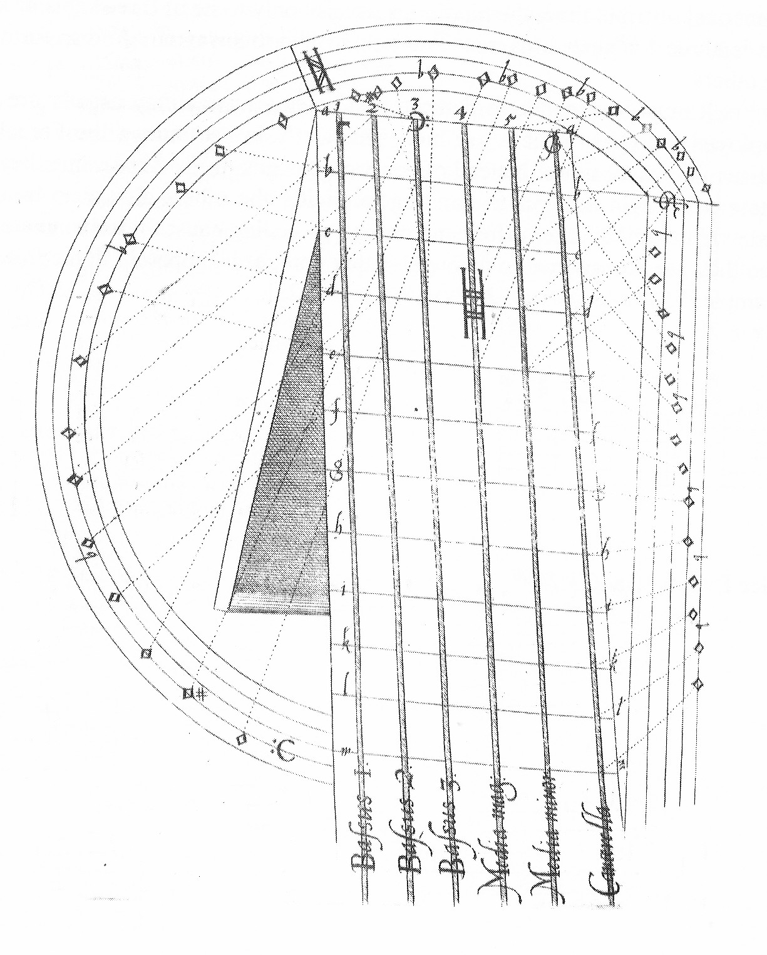

fludd_templeOfMusic_184_230_plate_6_4_BarbitumPitchCircle_lute.jpg

#### Fig. 8 Fludd’s Speculum adapted



A numbering starting with 0 instead of 1 would make the law  evident, e.g.,  (hundred thousand) is equal to , which is a one followed by five zeros.

#### Fig. 9 Descartes’s instrument to construct geometric progressions

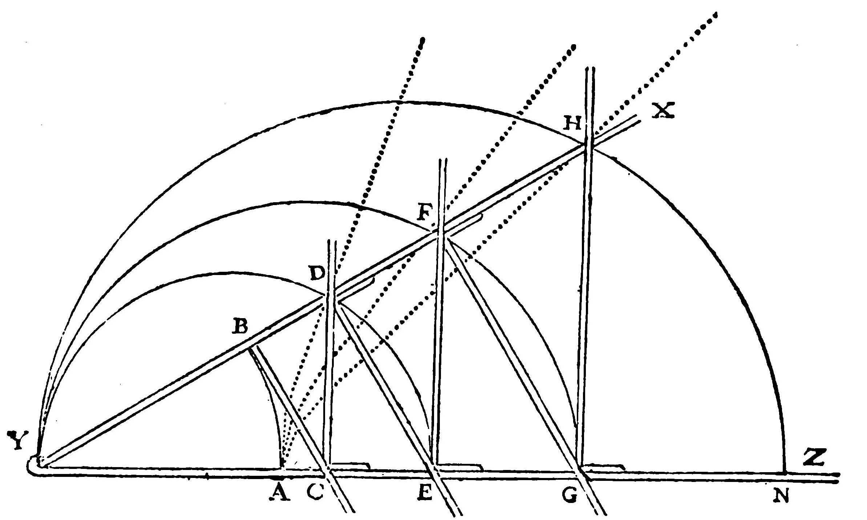

Descartes, Géometrie (1637) (mechanical tool for the construction of several intermediate geometric proportionals). The dotted curves are the graphs of the related power functions  with origin at A. They are the traces of pencils fixed at D, F and G on the underlying plane, while the angle XYZ is opened. The horizontal ruler YAZ is fixed. Descartes is familiar with these proportional compasses since 1619. The instrument with sufficiently many rulers could be used to determine mechanically the string length for equal temperaments.

#### Fig. 10 The division of the whole tone 9 : 8 into semi-tones 17 :16  and 18 : 17 (Zarlino 1571)

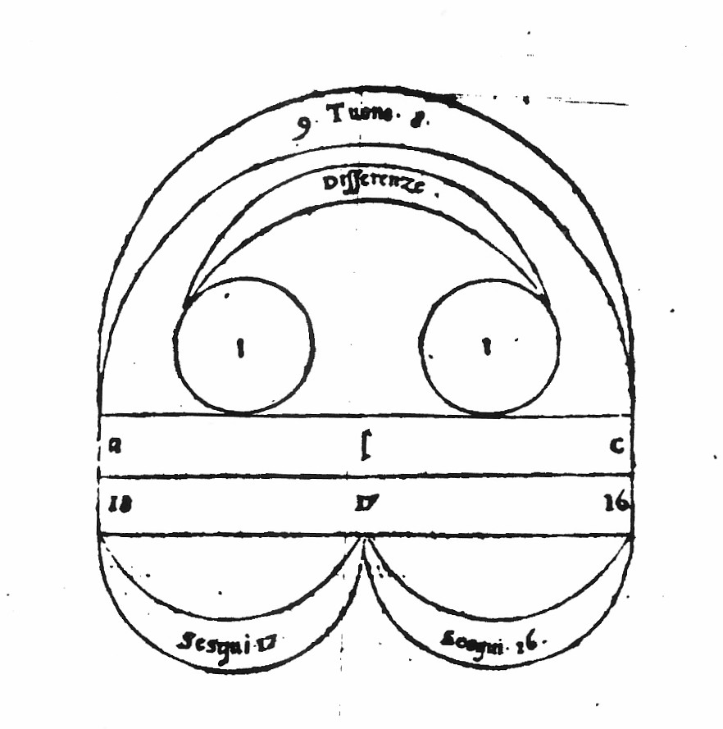

The division is already given by Boethius, ##

#### Fig. 11 Beeckman chromatic and diatonic scale

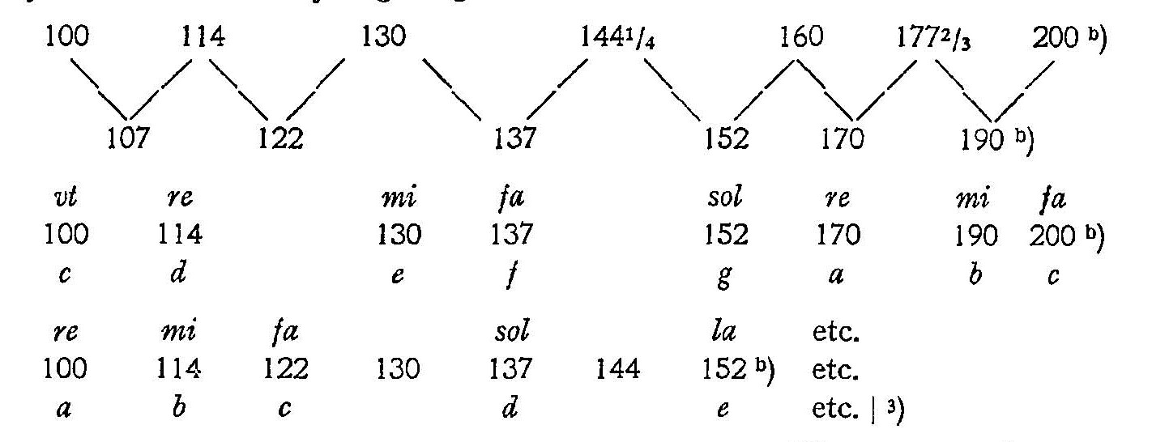

Beeckman 1614 [JIB I, Fol. 14r [Juillet 1613-Avril 1614] 29]

#### Table 1 Analysis of the chromatic scale given by Beeckman.

|  |  |  |  |  |  |  |  |  |
| --- | --- | --- | --- | --- | --- | --- | --- | --- |
|  | A | B | A / B | A / B [syntonic commas] | Guessed  rationalization |  |  |  |
| c = ut | 100 | 100 | 1.0 | 0 | 1 | 1 |  |  |
|  | 107 | 105.9 | 1.01039 | 0.832 | 16/15 | 1.14  8/7 |  |  |
| d = re | 114 | 112.2 | 1.01604 | 1.281 | 16/15 |  |  |
|  | 122 | 118.9 | 1.02607 | 2.072 | 16/15 | 1.1404  8/7 |  |  |
| e = mi | 130 | 126.0 | **1.03175** | **2.516** | 16/15 |  |  |
| f = fa | 137 | 133.5 | 1.02622 | 2.083 | 20/19 |  |  |  |
|  | 144.25 | 141.4 | 1.02016 | 1.607 | 10/9 | (10/9)3  = 1.372  190/137  =1.387 |  |  |
| g = sol | 152 | 149.8 | 1.01469 | 1.174 |  |  |
|  | 160 | 158.7 | 1.00819 | 0.657 | 10/9 | 5 / 4 |  |
| a = re | 170 | 168.2 | 1.0107 | 0.857 |  |
|  | 177.67 | 178.2 | **0.99703** | **-0.239** | 10/9 |  |
| b = mi | 190 | 188.8 | 1.00636 | 0.510 |  |
| c = fa | 200 | 200 | 1.0 | 0 | 20/19 |  |  |
|  |  |  |  | octave | 1.968 | 1.985 |  |  |

A: Beeckman/Stevin 1614

B: Stevin, *Vande Spiegheling*, scaled down from 5000/10000 to 100/200 (1 d.p.).

#### Table 2 Bürgi’s geometric/arithmetic progression

1.00010 = 1 = 1.0000

1.00011 = 1.0001 = 1.0001

1.00012 = 1.0002000 = 1.0002

1.00013 = 1.000300030001 = 1.0003

1.00014 = 1.0004000600040001 = 1.0004

…

1.0001100 = 1.01004966… = 1.0100

1.0001**101** = 1.01015067… = 1.0**102**

#### Fig. 12 Pascal’s Triangle according to Stifel 1544

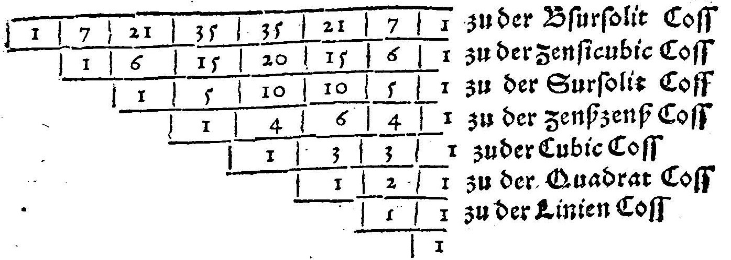

1554_Rudolff_Stifel_45_PascalTriangle.jpg

#### Fig. 13a Tetraktys



#### Fig. 13b Division of the octave 6 : 8 : 9 : 12( Zarlino 1571).

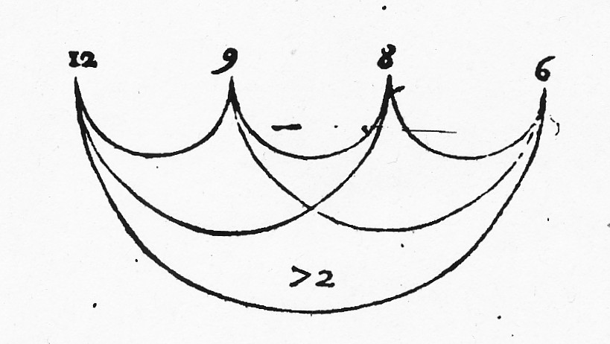

The division of the octave into two fourths with intermediate major tone 9 : 8, according to Zarlino (1571), leading to the proportion 6 : 8 : 9 : 12. The four numbers are arranged equidistantly as points representing numbers. The curved connections highlight all possible ratios. The related graph (points and connections) is isomorphic to a tetrahedron. This diagram is sometimes called the ‘second tetractys’.

#### Fig. 13c Division of the double octave 6 : 8 : 9 : 12 : 14 : 16 : 18 : 24 and the Pythagorean chromatic scale (Faber Stapulensis 1551, 32v)

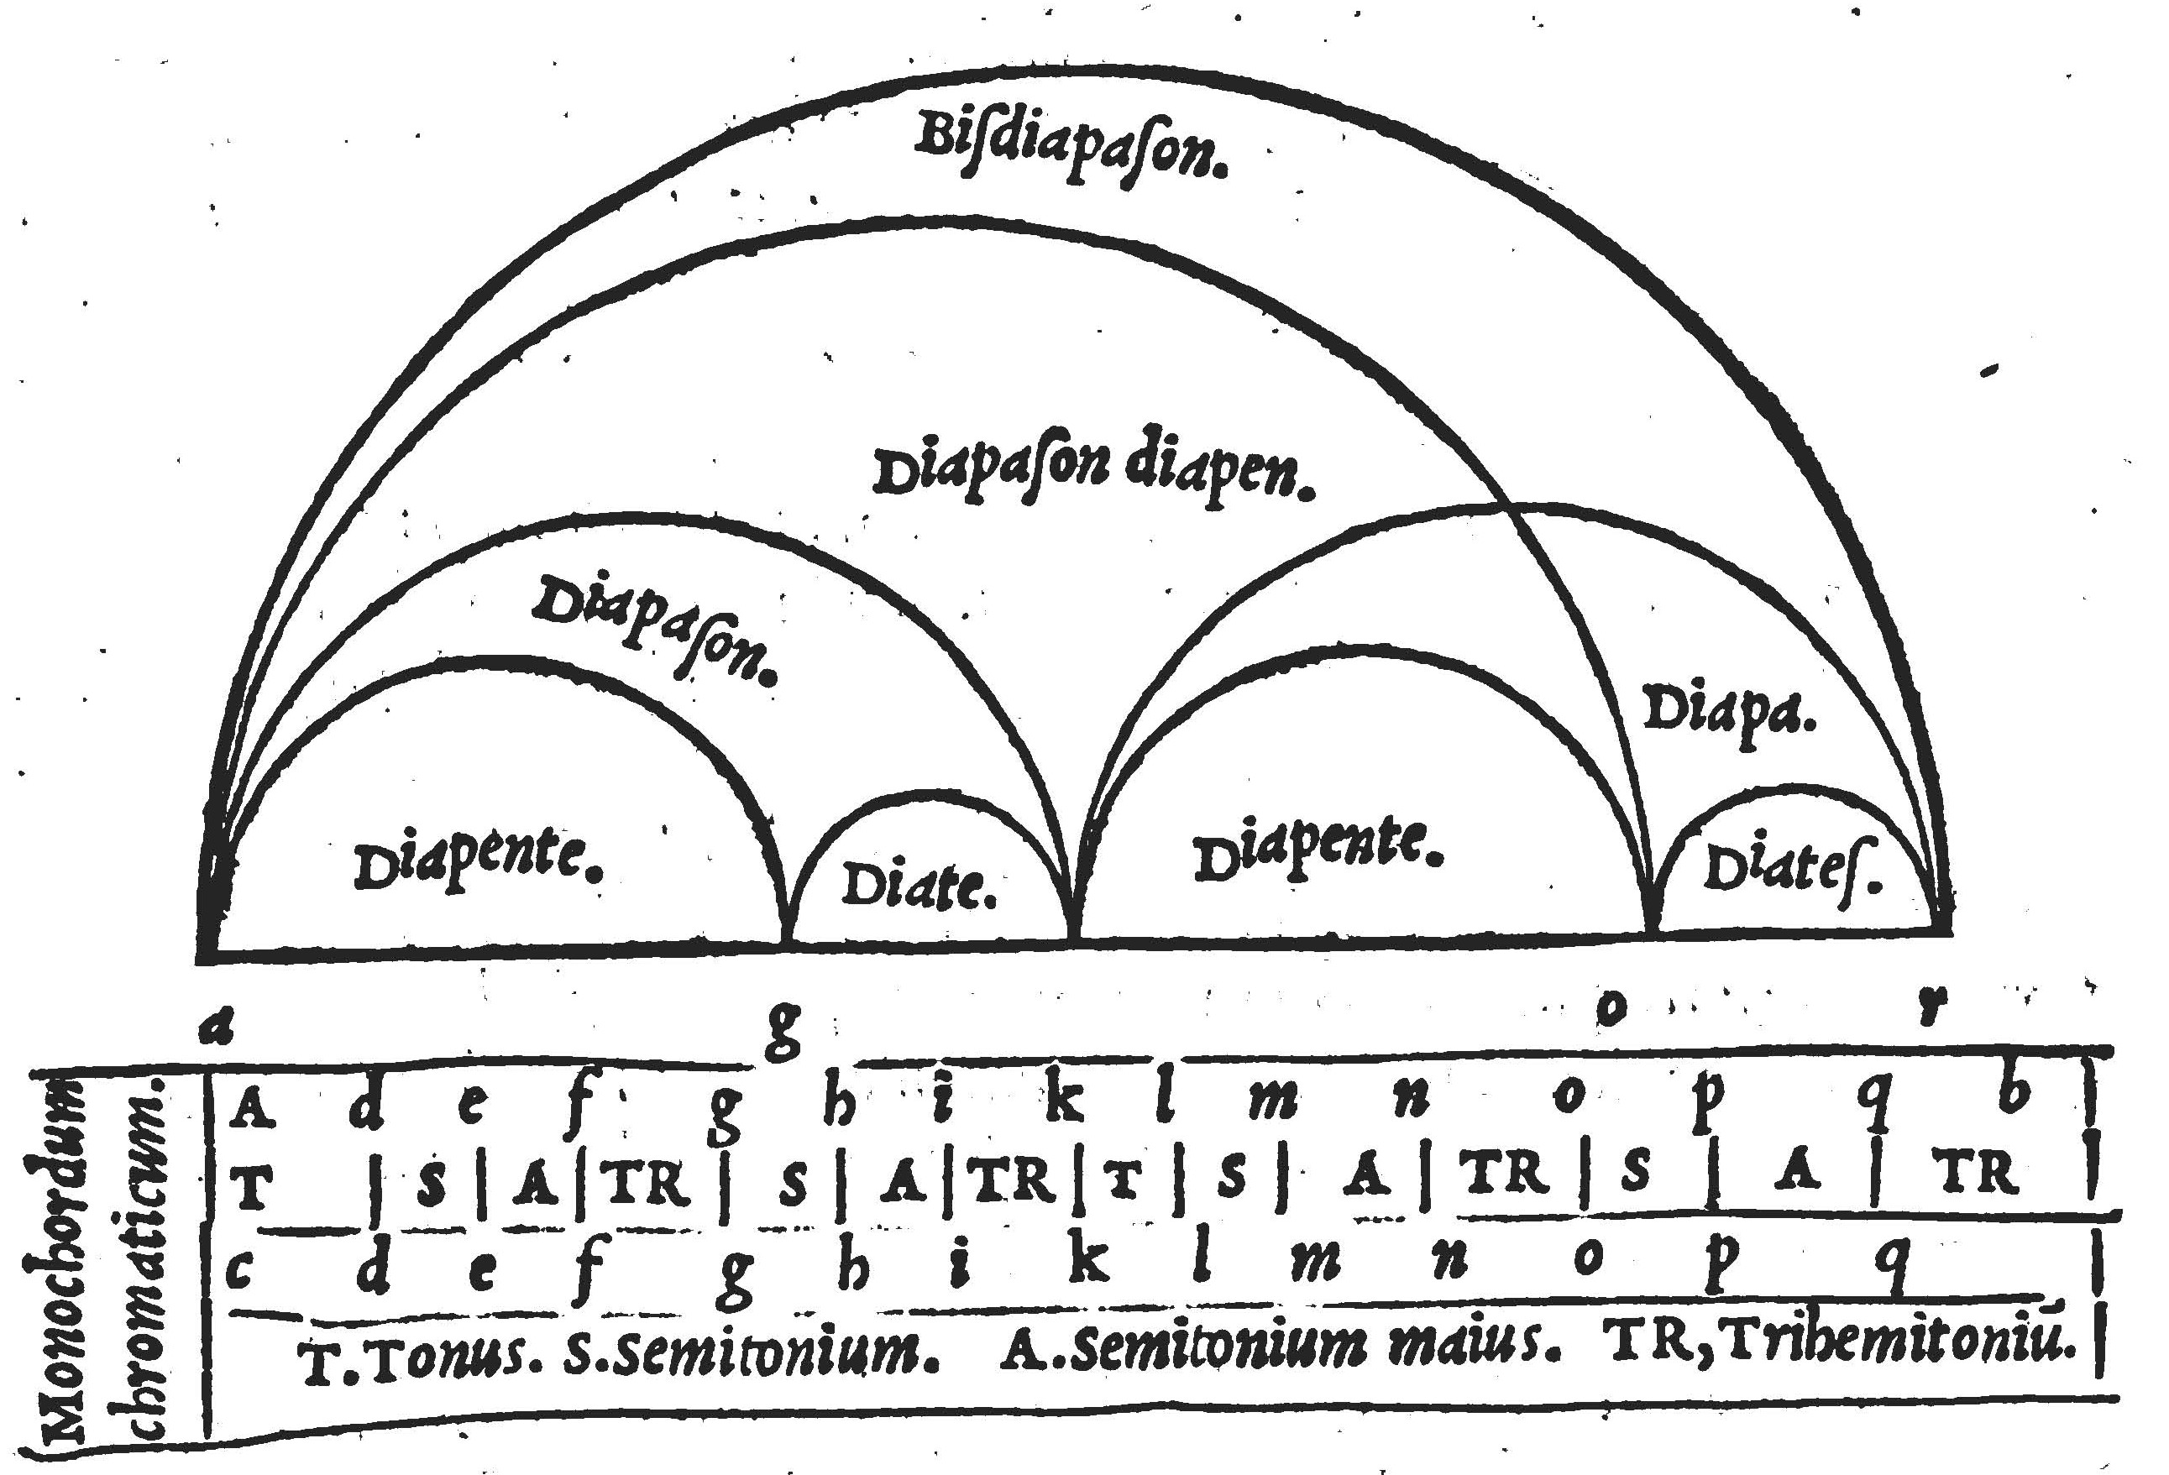

Both representations express a somehow logarithmic understanding of pitch and intervals. The second octave (Diapason) is an exact copy of the first. However, in the upper diagram the ratio between the fifth (Diapente) and the fourth (Diatessaron) is close to 2 : 1 instead of about 7 : 5. The left side of the lower diagram seems to graphically distinguish whole tones from semitones, however the three semitones TR are not wider than the tone. The caption ‘Monochordum chromaticum’ is rather misleading. The word ‘monochordum’ is uesed metaphorically for tone system, which is studied with the monochord, and ‘chromaticum’ refers to a Greek chromatic genus. It is  where the ordinary semi-tone () is Pythagorean  and the major semi-tone () is , which gives translated into modern notation d – e – f – f# – a – bb – c# – d (ascending) or d – c – b – bb – g – f# – eb – d (descending) in German notation (d, e, f, fis, a, b, cis, d versus d, c, h, b, g, fis, es, d). Note that the two tetrachords are neither symmetric nor congruent, so that ascending and descending scales with the same inner structure are essentially different.

#### Fig. 14a Power table (filled Lambda tetraktys)



Power table  for positive integers *k* and *m*.

#### Fig. 14b Fludd triangle

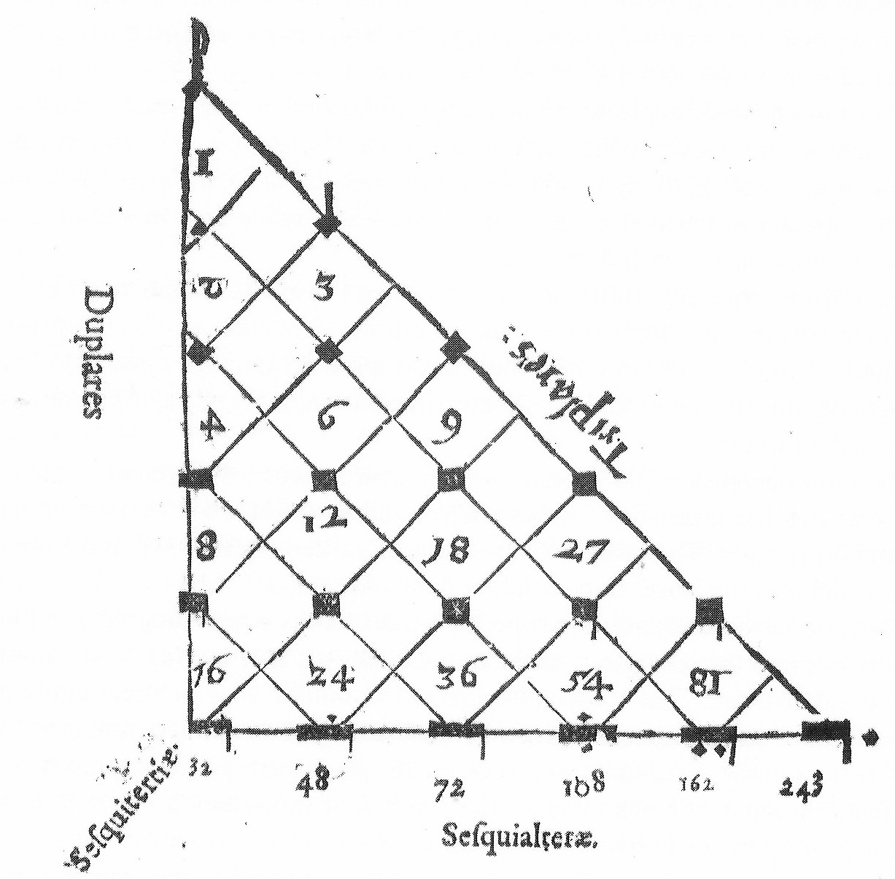

The diagram explains a sophisticated mensural notation system of the ars nova period (14th century), which freely combines binary with ternary multiples of the smallest value on top. Four directions, each of them defining geometric progressions (common factor *r*) are clearly indicated (*r* = 2: Duplares, *r* = 3 : Triplares, *r* = 3/2: Sesquialteræ, *r* = 4/3: Sesquitertiæ). As a consequence of the 45° angle at 1 the two directions Duplares and Triplares seem to be comparably scaled, however a closer inspection shows that fourths are wider than fifths.

#### Fig. 14c Torkessy etc (Reany/Gilles p. 28)

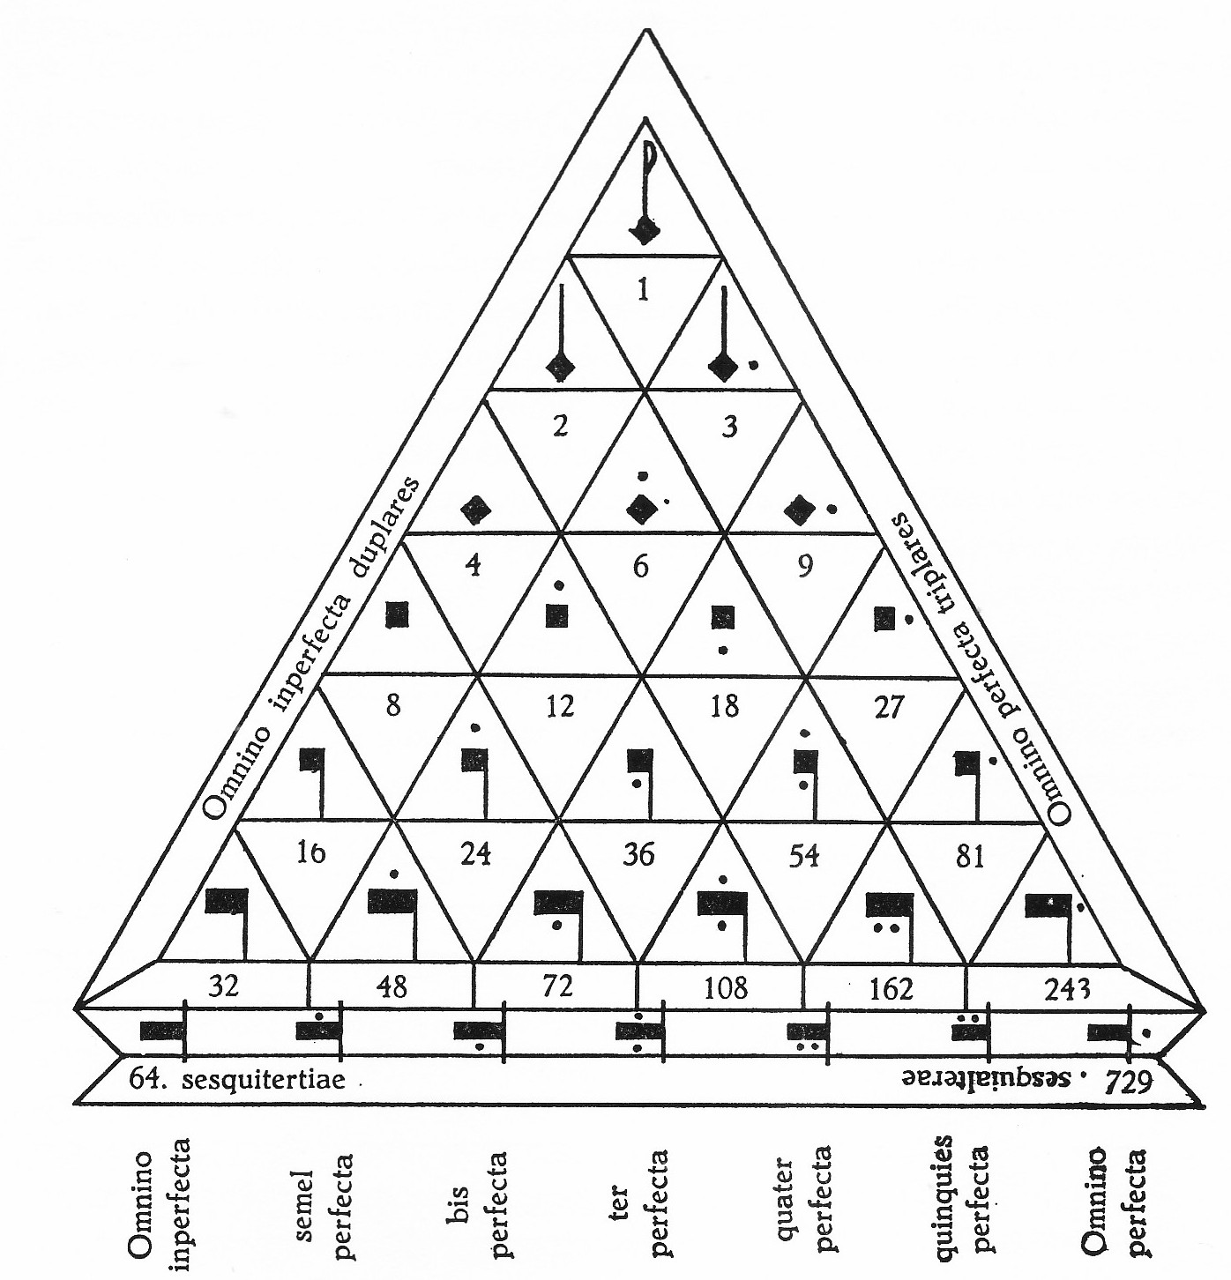

#### Fig. 14d Boethius Arithmetic triangle (Mh 1)

09xx_Boethius_DeInstitutioneArithmetica_Matrix_2011_Sonar_3000JahreAnanlysis_094_detail.jpg

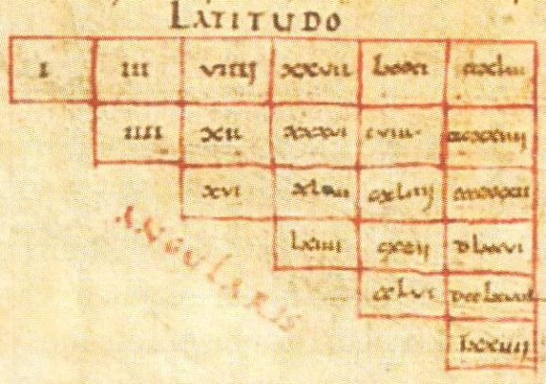

The horizontal direction of this number triangle (Latitudo) is multiplication by 3 (triplares), the diagonal direction (Angularis) is multiplication by four (quadruplares) and the unnamed vertically down direction is multiplication by four and division by three (sesquitertiæ) for example the fourth column down reads 27 – 36 – 48 – 64. The manuscript contains similar diagrams for 2/3, for 3/4 and for 4/5. It is mentioned in the text that with the aid of such triangles one can determine arbitrarily long geometric progressions for any superparticular ratio. Therefore, the triangle for the base numbers 80 and 81 with 56 rows and columns could be used in order to measure the octave in terms of syntonic commas and to determine the angles in Descartes’s diagrams. Writing  as an exact integer ratio needs 107 decimal digits in both, numerator and denominator.

#### Fig. 15 Power tables as a self-similar structure



#### Fig. 16 Two dimensional Pythagorean power grid.



#### Fig. 17a Diatonic Pythagorean scale



#### Fig. 17b 53 Pythagorean fifths filling Descartes’s pitch circle (n = 53).



The 53rd fifth in anti-clockwise (small dark point) almost coincides with the start point (bigger circle) at (1|0).

#### Fig. 18a Syntonic pitch grid (Rameau 1726)

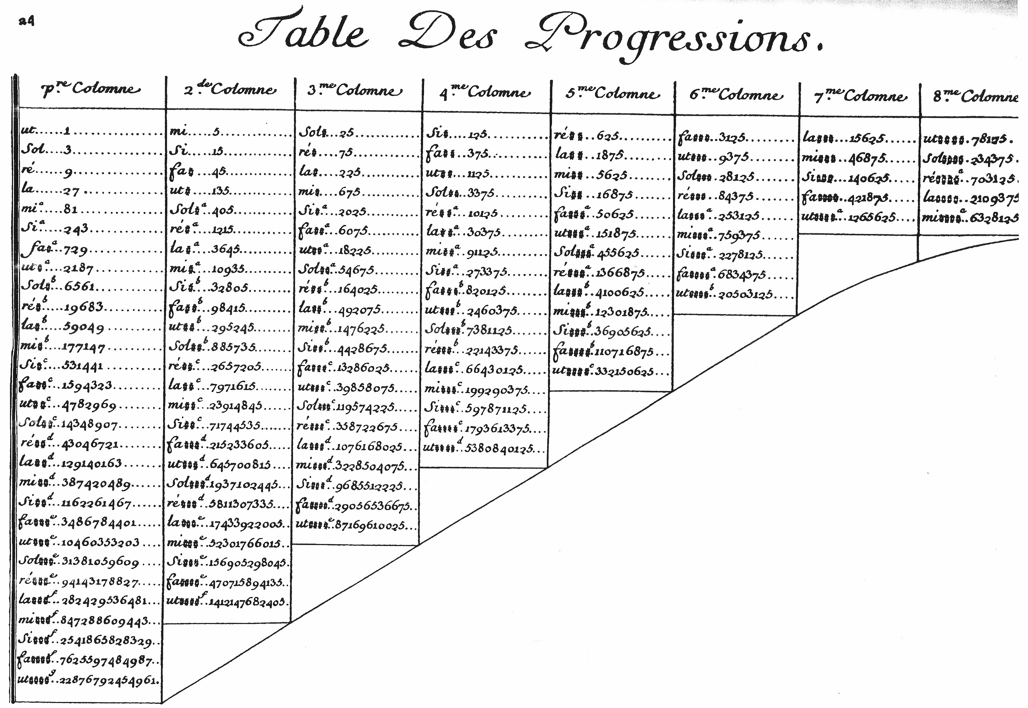

Table of pitch classes according to Jean-Philippe Rameau (1726). The power table with powers of 3 (Pythagorean fifths) in the vertical and powers of 5 (Syntonic thirds) in the horizontal direction contains pitch names in absolute solmization. The octaves, powers of two, do not occur at all. For example, the entry la### 15,625 in the first row means la increased by 3 semitones. This corresponds to 56/214 = 15,625 / 16,384 = 0.9537. In other words la### is almost a semitone, 24.64° degrees in Cartesian angles (3.8 syntonic commas) below ut (). However la### 1,076,168,025 =  leading to  is 1.17° in Cartesian angles (0.18 syntonic commas) above ut. Hence the two tones with the same name la### are 25.8° or 4 syntonic commas apart.

#### Fig. 18b 1739_Euler__Tentamen_147_ChromaticScale.jpg

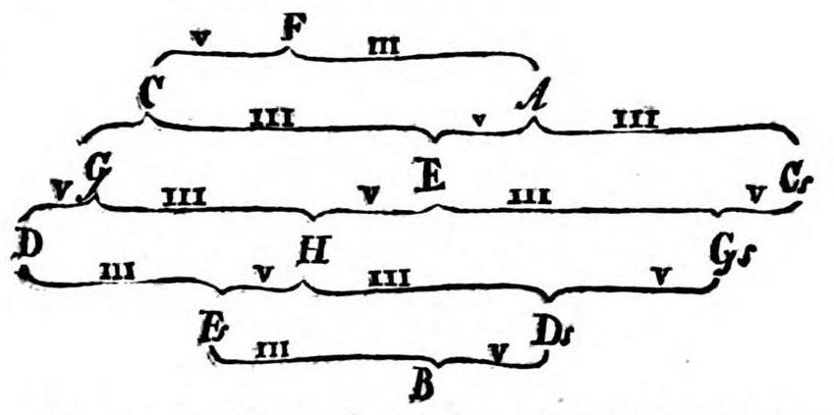

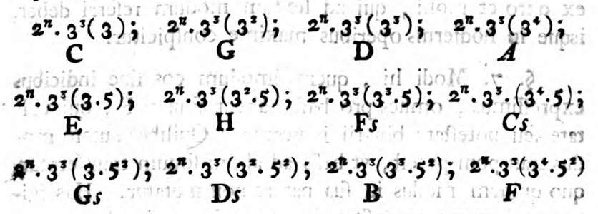

Above. The pitch classes of the diatonic chromatic scale according to Leonhard Euler. The direction of ascending fifths (V, powers of 3) is top right to bottom left, the direction of ascending major thirds is top left to bottom right (III, powers of 5). Note the enharmonic mistake at the bottom B (B-flat) should be As (A-sharp).

Below. Chromatic scale interpreted with powers of 3 and 5. The octaves are expressed as 2n. The common factor 33 seems to serve as a scaling factor for absolute pitch, leading to C 34 = 81. However, 35 leads to C = 243 and a = 405 if these numbers are interpreted in Hertz.

# Not used

#### Table 2 Multiple, superparticular ratios

**1 : 2 1 : 3 1 : 4** multiple 1 : n

1 : 2 **2 : 3 3 : 4** superparticular n : (n+1) difference 1

1 : 3 2 : 4 = 1 : 2 superbipartiens n : (n+2) difference 2

1 : 4 supertripartiens n : (n+3) difference 3

#### Table 3 The intervals of the tetraktys

1 : 2 / 2 : 4 dupla / diapason octave

1 : 3 tripla / twelfth

1 : 4 quadrupla / bisdiapason double octave

2 : 3 sesquialtera / diapente fifth

3 : 4 sesquiquarta / diatessaron fourth

#### Torkessy etc (Reany/Gilles p. 30, 61)

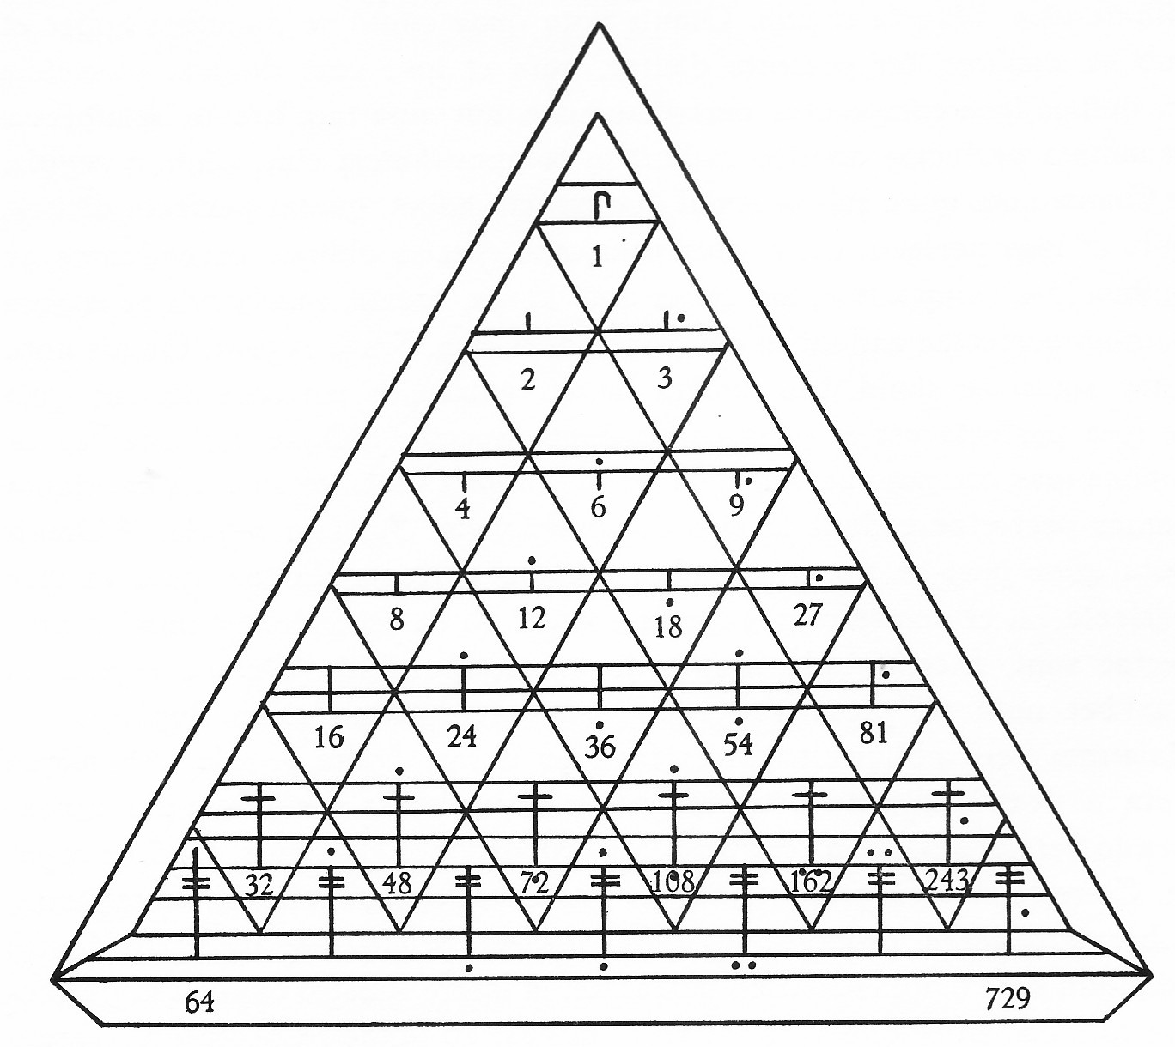

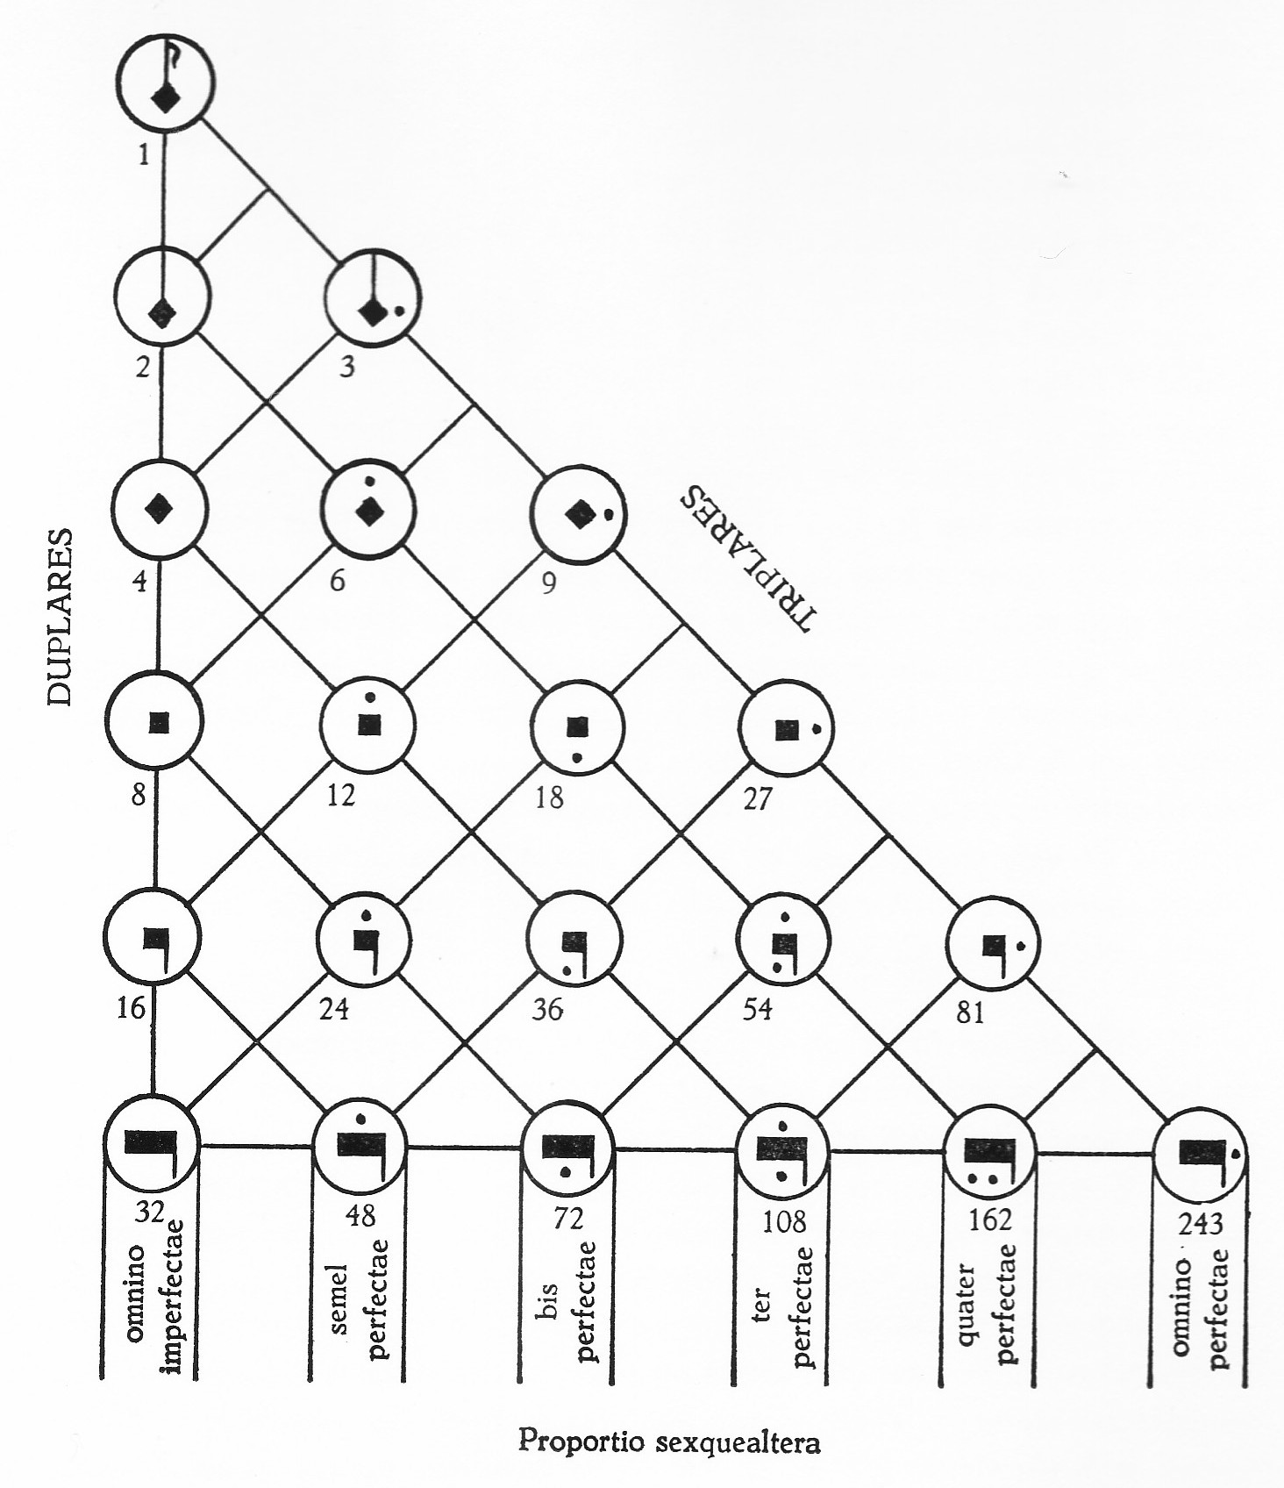

#### 1617_Fludd_1_Tract_I_Lib_VI_fol181_CausarumUniversaliumSpeculum.jpg

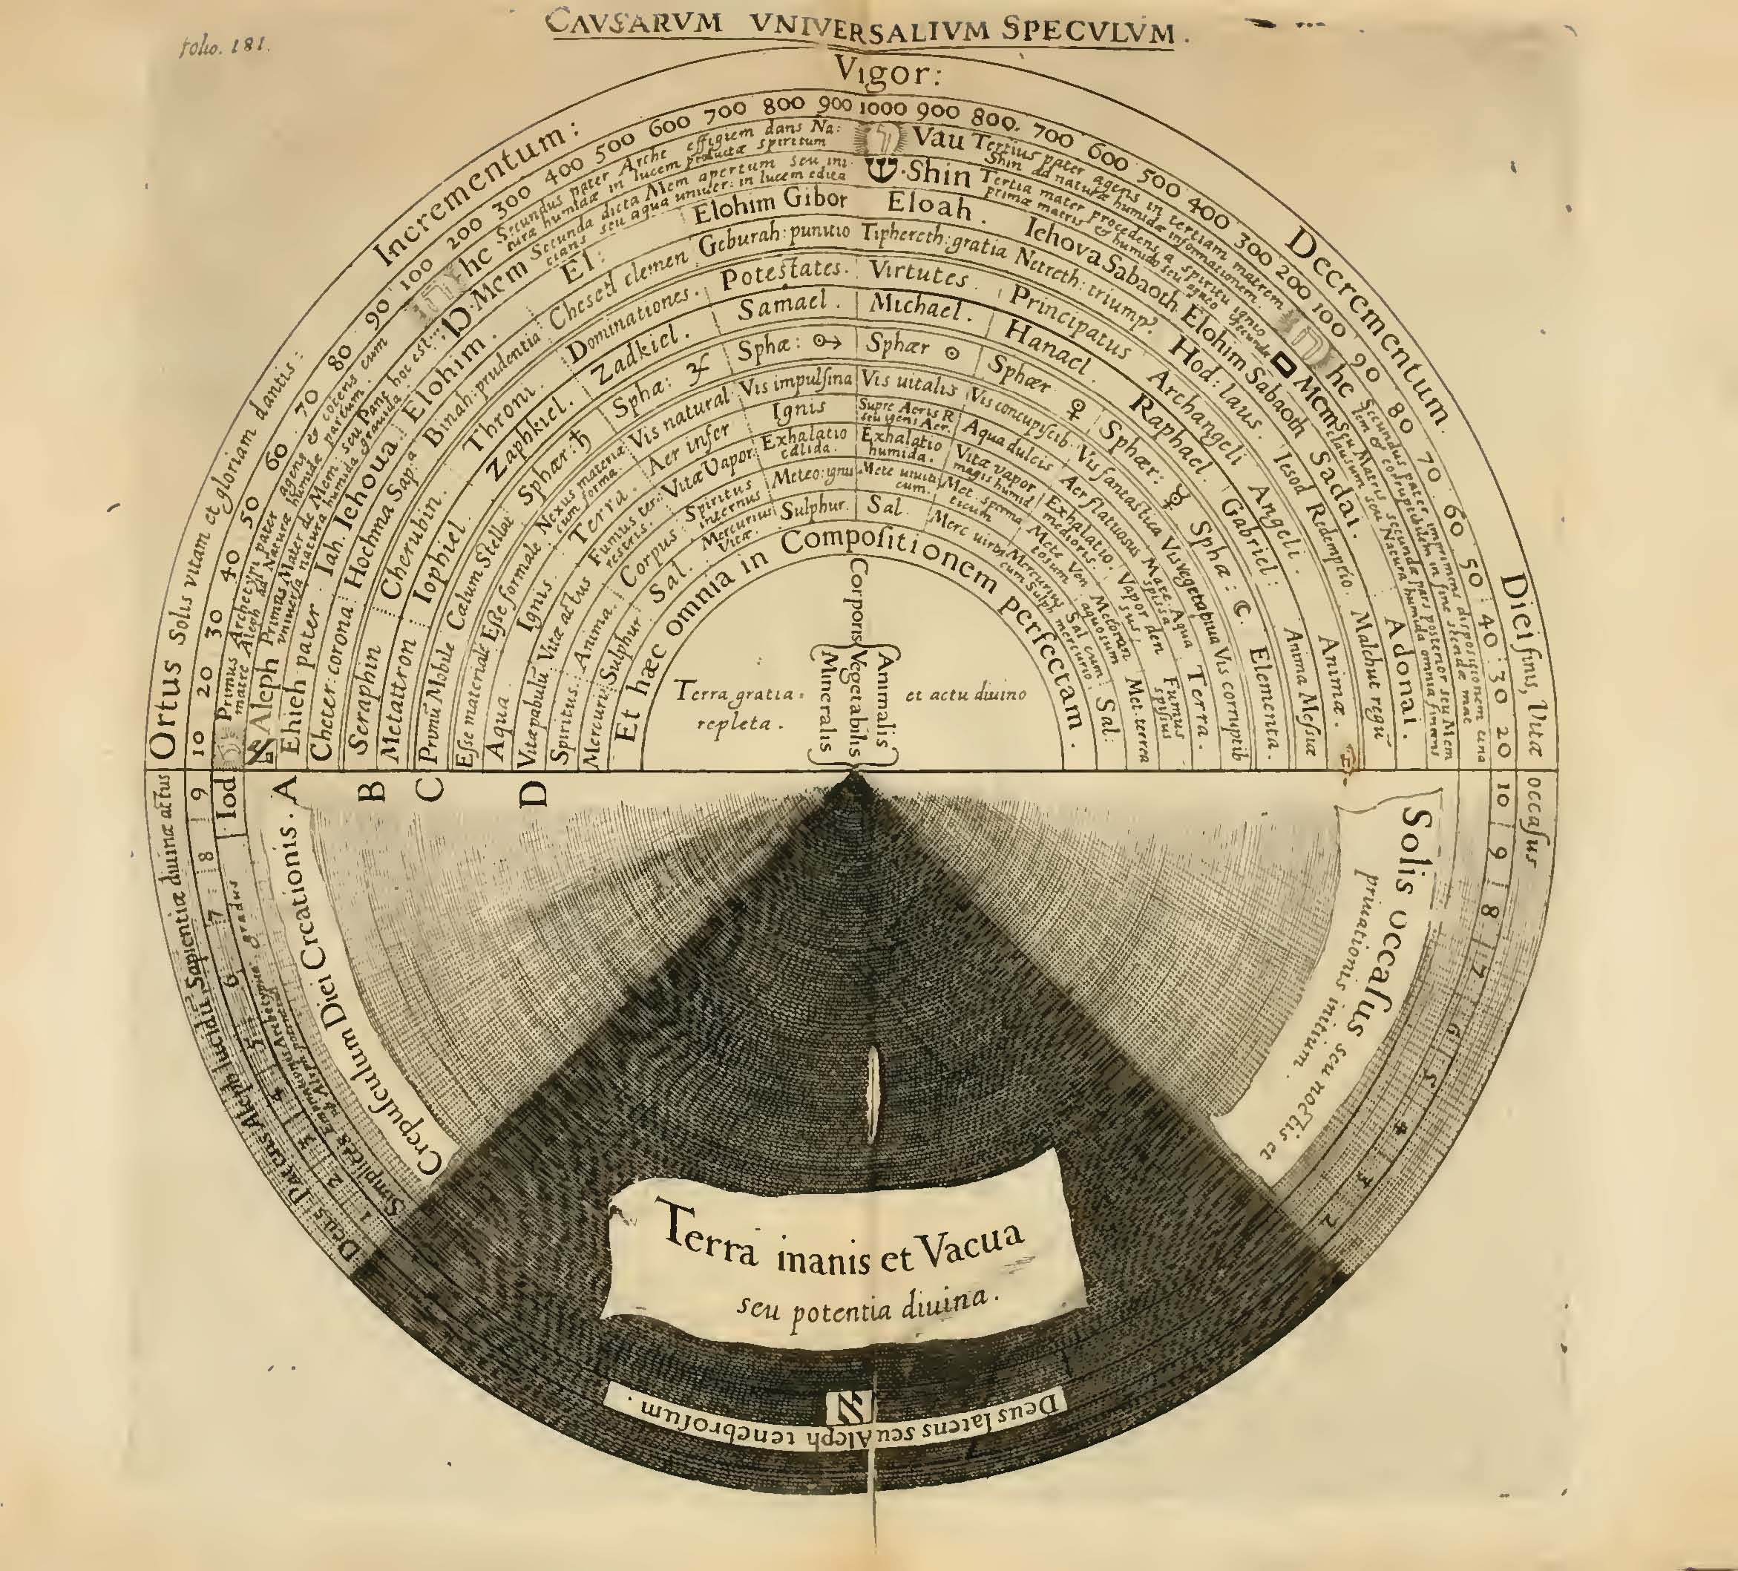

#### Ramon Llull, Ars brevis (1305)

1305_LlullRamon_lohri_AnnulusCombinatorics.jpg

